Use this guide to register for courses as a student in the Adult Degree Completion (ADC) program.

Register for an individual class
- Log into Workday and click the Academics app.

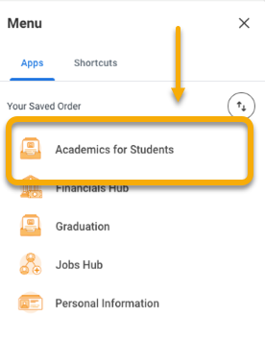

- Click the Registration tab.

- In the right-hand menu, locate the click “Find ADC Fall/Spring Course Sections”

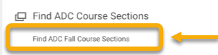

- Using the course search features, locate the course section for which you want to register.

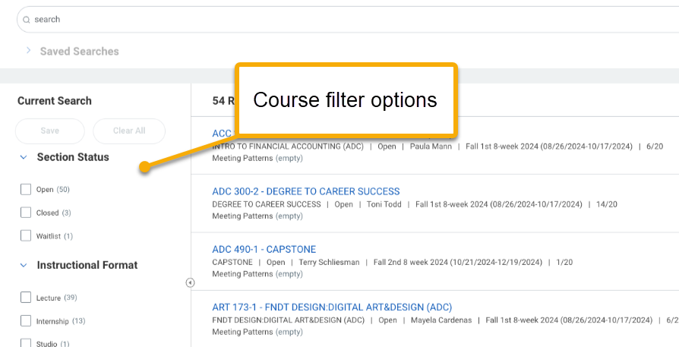

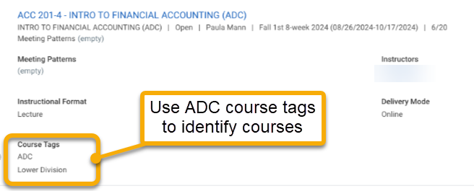

- Right click the desired course to open in a new tab.

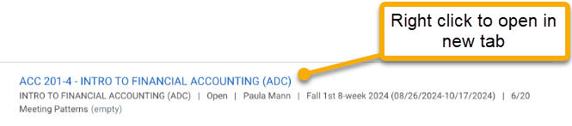

- The View Course Section page will display course details. Review carefully to ensure you are eligible and do not have schedule conflicts.

If you are not eligible to register for the course, you may see the Troubleshoot buttons.

If you are eligible to register, Workday will display the “Register” button.



- Click “Register”.

- On the Register for Course Section page, course sections may appear. Select the course section with your preferred meeting pattern and confirm the box in the Eligible column is checked.

- Click “Register”



You will receive one or more of the following messages:

Registration status | Description
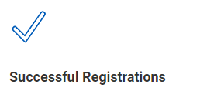 | This means you are successfully registered for the course. To view all your registered courses, click the “View Registered Courses” button.  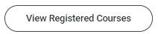
 | This means you are waitlisted for the course.  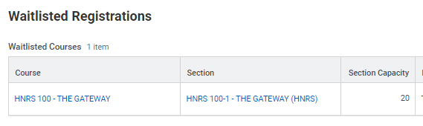
 | This means you are not successfully registered for the course. This may be the result of an unmet prerequisite, account hold, or schedule conflict. Reach out to your advisor for help.

